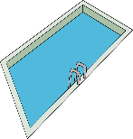 |  |  | Pool application checklist
☐ | Picture of the pool; Construction details
☐ | Locking Ladder details/ picture
☐ | Equipment (pump & filter) separation distance from pool (48” minimum)
☐ | Pool barrier design pictures and location R-326.4.2
☐ | Alarm details/ picture R-326.7 F-2208-14
☐ | Pump timer details / picture R-403.10.2 N1103.10.2
☐ | Copy of your electricians Orange County electrical license
☐ | Submit a true and accurate plot plan / drawing or survey of your property with:  - Pool location and distance to property lines, house and any other structures  - Pool must be minimum 10’ from property line and 10’ from house or any other structure  - Any other structures on your property (sheds, garage, etc...)  - Septic Tank and leach field location
☐ | Show all doors within the dwelling and their proposed alarms R-326.4.2.8-1a UL-2017
☐ | Show all windows and window locks R-326.4.2.8-1b (ASTM F-2090)
☐ | Pool barrier design pictures and location
☐ | Pool gate details:  - Gate height  - Self-closing  - Latch information (Must be self-latching)  - Gate Swing (Must swing outward – away from the pool) R-326.4.2.7
☐ | Show entrapment protection details (in-ground pool only) R-326.5
☐ | Show heated pool (R-Value) cover details (in-ground pool only) R403.10.1 N103.10.3
☐ | Insurance:  - Liability Insurance on an Acord form with the Town of Newburgh listed as certificate holder  - Workers Compensation on a C105.2 form with the Town of Newburgh listed as certificate holder OR  - Workers Compensation Exemption CE-200 form along with  - Homeowners Insurance Policy Declaration page
_______________________________________________________________________
** All applicable items must be submitted at time of permit application. **
** A third-party electrical inspection will be required prior to your final inspection in order to obtain a Certificate of Compliance. **
2020 RCNYS and 2020 ECCCNY Codes

☐ | N1103.10.2 (R403.10.2) Time switches. Time switches or other control methods that can automatically turn off and on according to a preset schedule shall be installed for heaters and pump motors. Heaters and pump motors that have built-in time switches shall be in compliance with this section.
☐ | [NY] R326.4.4 Prohibited locations. Barriers shall be located so as to prohibit permanent structures, equipment or similar objects from being used to climb the barrier
☐ | [NY] R326.4.2.8-1b: Operable windows in the wall or walls used as a barrier shall have a latching device located no less than 48 inches above the floor. Openings in operable windows shall not allow a 4- inch-diameter (102 mm) sphere to pass through the opening when the window is in its largest opened position; (ASTM F-2090)  [NY] R326.4.2.1 Barrier height and clearances. The top of the barrier shall be no less than 48 inches (1219 mm) above grade measured on the side of the barrier that faces away from the swimming pool. The vertical clearance between grade and the bottom of the barrier shall be not greater than 2 inches (51 mm) measured on the side of the barrier that faces away from the swimming pool. Where the top of the pool structure is above grade, the barrier may be at ground level, or mounted on top of the pool structure. Where the barrier is mounted on top of the pool structure, the barrier shall comply with Sections R326.4.2.2 and R326.4.2.3.
☐ | [NY] R326.4.2.7.1 Self-closing and opening configuration. All gates shall be self-closing. In addition, if the gate is a pedestrian access gate, the gate shall open outward, away from the pool.
☐ | [NY] R326.4.2.7.2 Latching. All gates shall be self-latching, with the latch handle located within the enclosure (i.e., on the pool side of the enclosure) and at least 40 inches (1016 mm) above grade. In addition, if the latch handle is located less than 54 inches (1372 mm) from grade, the latch handle shall be located at least 3 inches (76 mm) below the top of the gate, and neither the gate nor the barrier shall have any opening greater than 0.5 inch (12.7 mm) within 18 inches (457 mm) of the latch handle.
☐ | [NY] R326.4.2.7.3 Locking. All gates shall be securely locked with a key, combination or other child-proof lock sufficient to prevent access to the swimming pool through such gate when the swimming pool is not in use or supervised.
☐ | [NY] R326.4.2.8 Dwelling wall as barrier. A wall or walls of a dwelling may serve as part of the barrier, provided that the wall or walls meet the applicable barrier requirements of Sections R326.4.2.1 through R326.4.2.6, and one of the following conditions shall be met:  a) Doors with direct access to the pool through that wall shall be equipped with an alarm that produces an audible warning when the door and/or its screen, if present, are opened. The alarm shall be listed in accordance with UL 2017. The audible alarm shall activate within 7 seconds and sound continuously for a minimum of 30 seconds after the door and/or its screen, if present, are opened and be capable of being heard throughout the house during normal household activities. The alarm shall automatically reset under all conditions. The alarm system shall be equipped with a manual means, such as touch pad or switch, to temporarily deactivate the alarm for a single opening. Deactivation shall last for not more than 15 seconds; and  b) Operable windows in the wall or walls used as a barrier shall have a latching device located no less than 48 inches above the floor. Openings in operable windows shall not allow a 4- inch-diameter (102 mm) sphere to pass through the opening when the window is in its largest opened position; and  c) Where the dwelling is wholly contained within the pool barrier or enclosure, alarms shall be provided at every door with direct access to the pool; or 2. Other approved means of protection, such as self-closing with self-latching devices, so long as the degree of protection afforded is not less than the protection afforded by Item 1 described above.
☐ | [NY] R326.4.2.8.1 Alarm deactivation switch location. Where an alarm is provided, the deactivation switch shall be located 54 inches (1372 mm) or more above the threshold of the door. In dwellings required to be Accessible units, Type A units, or Type B units, the deactivation switch shall be located 48 inches (1219 mm) above the threshold of the door.
 | POOL ALARM & PUMP TIMER EXAMPLES
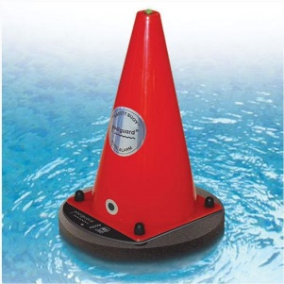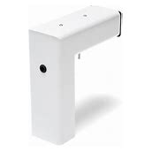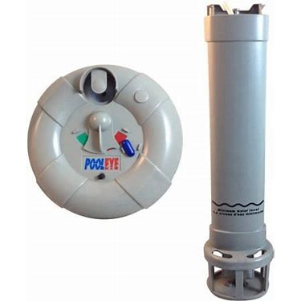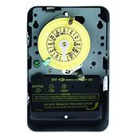
Pool alarm in-ground pool alarm above ground pool alarm Intermatic pump timer

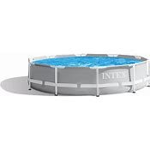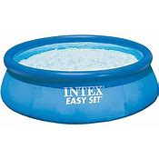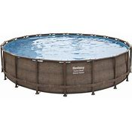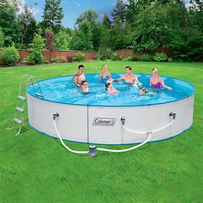
**FYI: The above pictured pools require a 48” barrier around them**

